Free Being Me
New Badge Competition

WAGGGS is calling on creative minds everywhere to design a brand-new badge for our body confidence programme! This is your chance to turn the powerful messages of Free Being Me (FBM) into a design that celebrates confidence, self-love, and diversity in all its forms.
Here’s the twist: Your design must speak without words (using images only) so it can be understood and loved by girls and young people all around the world.
Think bold. Think inclusive. Think YOU.
Make sure your design reflects the spirit of FBM and aligns with WAGGGS and Dove branding guidelines. And most importantly, have fun with it!
Section 1: About the Competition
Why do we need a new Free Being Me badge?
Free Being Me (FBM) is a global WAGGGS programme launched in 2013 in partnership with the Dove Self-Esteem Project. Through fun and interactive activities, FBM explores body confidence and self-esteem, challenges unrealistic beauty standards, and celebrates what makes each of us unique.
And guess what? It’s already reached over 8 million girls and young women worldwide!
Now, 13 years later… it’s time for a brand-new badge 🎉
Haven’t tried Free Being Me or Action on Body Confidence yet? No worries!
Why not start with one of our taster activities! Download and experience the Camping with Confidence Pack to to explore the topic with your group and get inspired to create an amazing badge design: https://free-being-me.com/downloads/
Who can take part?
- If you’re a Girl Guide or Girl Scout under 35, this is for YOU, wherever you are in the world!
- You can join in solo or as a team, so grab your friends if you want to create together.

How to submit your badge design?
- Send your design through your group leader — they’ll submit it to WAGGGS for you through freebeingme@wagggs.org
- Group leaders, quick heads up: Please make sure parents/guardians know about the competition, and don’t forget to let your Member Organisation (MO) know you’ve entered.

When is the competition open?
Competition will run from 15 April to 30 May 2026. Entries must be submitted before midnight (UTC) of 30 May 2026.

What are the submission requirements?
🎨 A digital image or a clear scan/photo of your badge design
🌈A note showing the colours you’ve used
✅ Important things to remember:
- Your design must follow WAGGGS safeguarding policy and FBM Brand Guidelines
- Keep it 100% original — this is your moment to shine! ✨
- No AI tools please 🚫🤖 — we want to see your creativity, ideas, and unique style

How will the competition be judged?
- Your designs will be reviewed by a panel of young judges selected by WAGGGS
- Each entry will be checked against the criteria in Section 2
- The judges will shortlist the entries and pick the top 5 designs
- The shortlisted designs will then be shared for global voting by young people from WAGGGS MOs across the globe
- 1st and 2nd Runners-up will receive: Certificates and 100 badges of the new badge
- The Winning team or individual will receive the following for their MOs: FBM merchandise pack - 100 badges, 100 limited edition FBM t-shirts, 50 limited edition FBM pins (new ones), and a small grant of £500 to implement FBM in their specific unit (Which can be used for printing, materials, or an FBM event)

Link to Relevant Policies and Guidelines
- WAGGGS Safeguarding Policy (WAGGGS Safeguarding Policy)
- FBM Brand Guidelines (FBM Badge Competition_Brand Guidelines and Logos)

Section 2: Badge Design Criteria

- Alignment with FBM messages

The design clearly reflects the aims of Free Being Me, including:
- Promoting positive body confidence and self-esteem
- Valuing diversity and individuality
- Challenging unrealistic beauty standards

The message should be clear, inclusive and appropriate for all WAGGGS age groups.

- Mandatory branding and technical requirements
All badge designs must meet the following requirements:
Colour palette:  - No more than five (5) colours  - Colours must be taken only from the official FBM colour palettes  (Please refer to the FBM brand guidelines pack) | 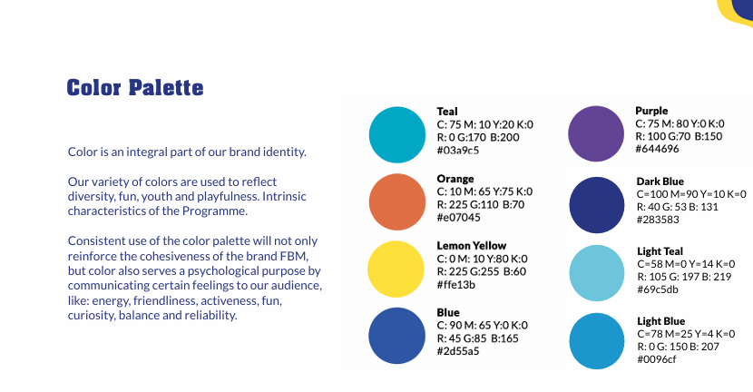
Text:
- No words, letters, or numbers may be used
- No reference to any language
- Images and symbols only

Badge size:
- Design must follow standard badge dimensions suitable for uniform and remains clear and recognisable at standard badge size.
- Minimum Dimensions: minimum size for badge on materials is 20mm- 30mm for the full badge.
Partner logo:  - The Dove partner logo must be included in the badge design. (Click here for Hi-Res image) | 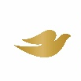

- Creativity and Visual Communication
- A creative and engaging visual concept
- Effective use of imagery to communicate meaning without words
- Design is empowering, inclusive, and welcoming

Remember: try not to make the design too complicated – it needs to be suitable for production.

Applicant Information

Member Organisation / Component Association
Country
Contact name
Role/position
Contact email address
Language(s) spoken

1.2. Team Involved in the Design

Please list in the table below all team members who were involved in the design implementation.

Team Member Names | Role/Responsibility in the MO | Email Address

Section 3: Your Submission

Design prototype:

Design or link to design:  (You can include a copy of the design here or share the link to the design. ex. Canva link or link to GDrive where we could access the badge design) | Detailed description of items on the design:

Section 4: Declaration

I confirm that...
- This design meets the criteria set out in section 2 of the competition pack.
- I have notified the parents/guardians of the young people who designed this badge that they are taking part in this competition.
- This is an original design with no use of AI tools to develop or generate the design.

Signature of Applicant(s):
__________________________________________________________________________
Signature of Group Leader:
__________________________________________________________________________

